**RDBMS Lab Experiment**

1. Create a Simple Trigger that does not allow Insert Update and Delete Operations on the Table
2. Create a Trigger that raises an User Defined Error Message and does not allow updating and Insertion
3. Write a procedure raise_sal which increases the salary of an employee. It accepts an employee number and salary increase amount. It uses the employee number to find the current salary from the EMPLOYEE table and update the salary.
4. Write a PL/SQL procedure called MULTI_TABLE that takes two numbers as parameter and displays the multiplication of the first parameter till the second parameter.
5. Write a procedure to calculate total for the all the students and pass regno, mark1, & mark2 as arguments.

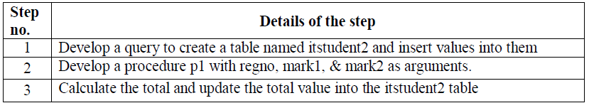

1. Create a procedure that has at least five parameters which takes input from at least three tables. Your task is to retrieve information from these tables and show the result (stored procedure output) in crystal report. Also develop a User Interface that has text box which will be linked with stored procedure parameter. When you increase or decrease parameter in stored procedure the UI will be updated automatically and show the result in another UI.
2. Create a tigger that will automatically fire when you increase or decrease/insert/delete/update from a given table and stored the old_value and new_value to another table.
3. Suppose you are given a table (student) of 10 colums.Your tasks is to create a tigger that will fire when you insert value to student and stored the similar column value to another three table which columns are combination of student table.
4. You are given a table name population. Which includes NID, Name, Date of Birth. You are also given two table dead_people and Birth_people. Your task is create a tigger that will automatically fire when any child born (Birth_people table) it will automatically fire and update the value in population table. Similarly when any people die (Birth_people table) it will automatically fire and decrease the value in population table